MS Word -Page Setup:
Paper size: A4 ( 210mm x 297mm);
Page margins: Top 25mm, Bottom 25mm Left 25mm Right 20mm,
Font: Times New Roman, Spacing: 1.5 spacing
Title of the Paper (Times New Roman 16 pt. bold, Center)

A. One*, B. Two², and C. Three³ (Times New Roman 12pt, bold, Center)
1:Fuel Chemistry Division, 2:Fuel Reprocessing Division, Japan Atomic Energy Agency, 3:Fuel Chemistry Division, Central Research Institute of Electric Power Industry (Times New Roman 10 pt, center)

Please write short abstract with a few lines. Short abstract, short abstract, short abstract, short abstract, short abstract, short abstract, short abstract, short abstract, short abstract, short abstract, short abstract.
Keywords: 5-10key words, Times New Roman 11 pt

Introduction (Section Heading (Times New Roman 12pt, bold)
Neither the sections nor the subsections need to be numbered. One line spacing separates the section headings from the preceding and the following paragraphs. Please arrange sections and subsections and their names as you like.
The text on each page should be contained within an area of 160 mm x 247 mm. The text should be in Times New Roman font, 10pt. The page limit is 4 pages (minimum 1 page).

Experimental
All Figures/Photographs and Tables should be numbered in Arabic numerals separately in the order of appearance in the text. The figures / photographs and tables should be in black and white. All Tables should be numbered with a descriptive title at the top in Times New Roman font 10 pts. All Figs/photographs should be numbered with captions in Times New Roman font 10 pt at the bottom.
We recommend that you convert charts and tables to JPG, PNG, or GIF if possible, and trim them before pasting them without using Word's functions to hide unnecessary parts. If the file size becomes large, we recommend compressing the diagram within Word.

Results and Discussion
Reference in the text should be in square bracket e.g., [1, 3-7]
Results and discussion ……… Figure 1 shows Cyclic voltammograms for element1, which were obtained by the method A[1].
Results and discussion and results and discussion and results and discussion a and results and discussion and results and discussion[2, 3].
Table 1 shows the results of the experiments………..
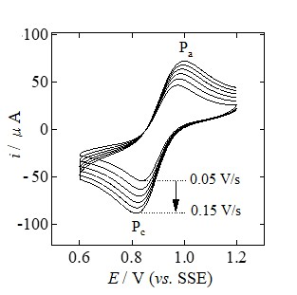

Figure 1. Cyclic voltammograms for element1

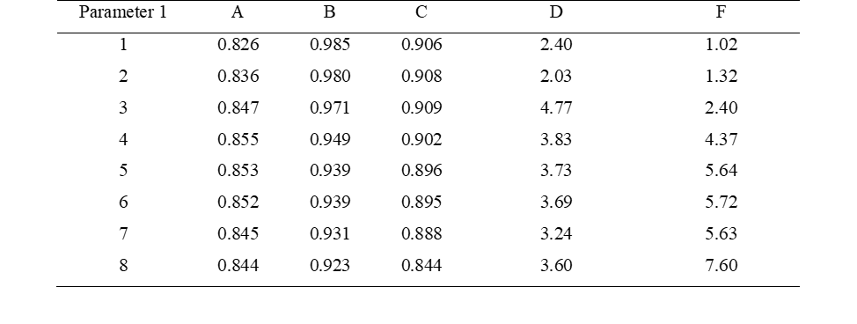
Table 1 Results of the experiments
Conclusion
The conclusion of the present study is ………
.
Acknowledgements

References
- Author A, Author B. J. Nucl. Sci. Technol. 2000;123(2):456. [Journals : Family name Initial of first name and middle name. Abbreviated Journal Title. Year, volume(number):pages.]
- Author C, Author D, et al. 2014, JAEA Research 2014-098. [Report : Family name Initial of first name and middle name. Year, Report No..]
- Author X. Hand Book of Nuclear Chemistry, Vol. 1, 3rd Edition, Eds. Editor A and Editor B, Publisher, City, Year, p.xxx. [Books]
- Author Y, Author Z. Proc. of GLOBAL2011, 2011 Dec. 11-16, Makuhari, Japan, (Paper No. 0101234) [CD-ROM]. [Proceedings : Family name Initial of first name and middle name. Conference name. Year Month Day, Place, (Paper No. if available).]

* Corresponding author. Email:one.a@jaea.go.jp

